Threat Hunting Report
Threat Hunting Activity Report
Analyst Information
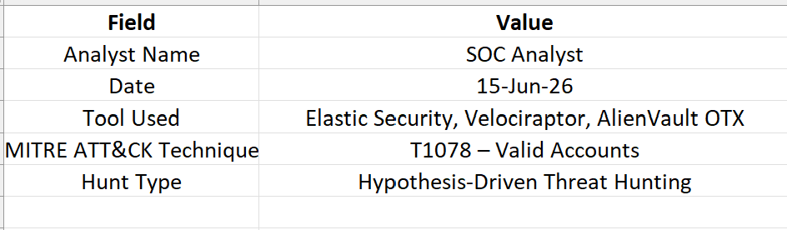
Objective
The objective of this threat hunting exercise was to proactively identify signs of unauthorized privilege escalation and misuse of valid user accounts within the enterprise environment. The investigation focused on detecting suspicious administrative privilege assignments that may indicate account compromise or insider threats.

Hunting Hypothesis
An unauthorized user may have obtained valid credentials and escalated privileges to gain administrative access within the network environment.
The hunting process focused on identifying Event ID 4672 (Special Privileges Assigned to New Logon), reviewing user activities, and validating findings against threat intelligence indicators.

Data Sources Utilized
- Elastic Security Logs
- Windows Security Event Logs
- Velociraptor Endpoint Data
- AlienVault OTX Threat Intelligence Feed

Investigation Procedure
Step 1: Log Collection
Security logs were collected from monitored endpoints using Elastic Security. Particular attention was given to privileged account activities and successful logon events.
Step 2: Event Filtering
Event ID 4672 was used as the primary hunting indicator because it records special privilege assignments granted during user logon.
Step 3: Threat Intelligence Validation
Observed IP addresses and account activities were compared against AlienVault OTX threat intelligence indicators.
Step 4: Endpoint Verification
Velociraptor was used to examine active processes and user activities on affected systems.

Findings
Privilege Escalation Events
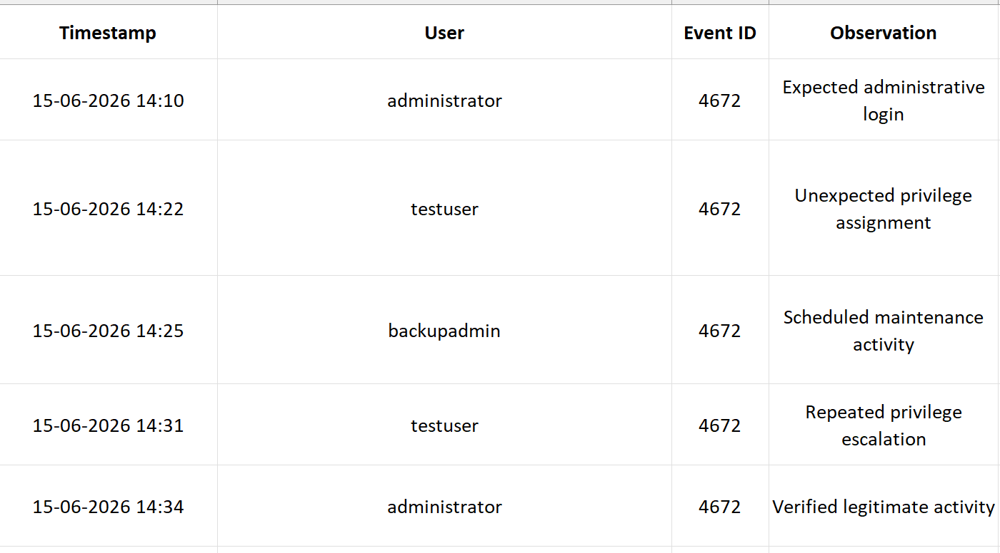Suspicious Indicators
- Multiple privilege escalation events were detected from the account "testuser".
- The account was not listed among approved administrative users.
- Repeated administrative privilege assignments occurred within a short time period.
- Activity pattern was inconsistent with normal business operations.

MITRE ATT&CK Mapping
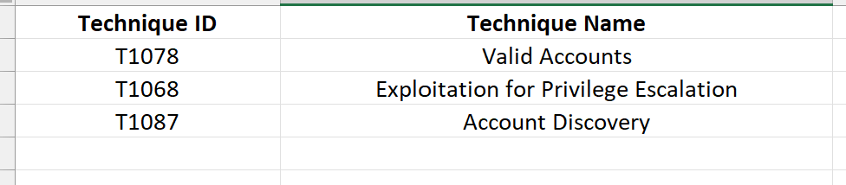

Threat Intelligence Results
AlienVault OTX analysis did not identify known malicious IP addresses associated with the observed activity. However, behavioral indicators suggested possible misuse of legitimate credentials.

Assessment
The investigation identified suspicious privilege escalation behavior associated with the account "testuser." Although no confirmed compromise was detected, the activity represents a potential security risk requiring additional monitoring and account validation.
Risk Level: Medium

Recommendations
- Disable or review unnecessary privileged accounts.
- Enforce Multi-Factor Authentication (MFA) for administrative users.
- Implement enhanced monitoring for Event ID 4672.
- Conduct regular account audits and privilege reviews.
- Create detection rules for repeated privilege escalation events.

Conclusion
The threat hunting exercise successfully identified abnormal privilege escalation behavior that could indicate misuse of valid credentials. By applying a hypothesis-driven hunting methodology and leveraging multiple data sources, suspicious account activities were detected and documented. Continuous threat hunting activities should be maintained to improve organizational security posture and reduce attacker dwell time.

